Group 30

Dean Meluban, Matthew Grande, Mike Bucyana, Tudor Gurau

MMTD Gyms

Track | Compare | Optimize

1. We got 100% on part one, relational schema remains the same as follows:

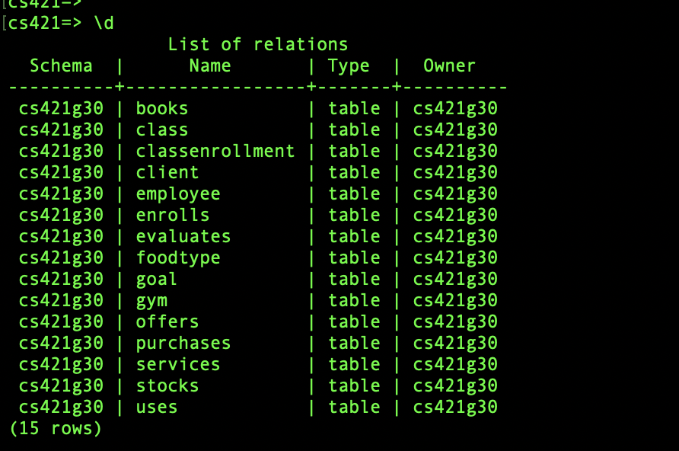**2)** Tables:

CREATE TABLE Gym(streetAddr VARCHAR(200), city VARCHAR(200), province VARCHAR(200), maxNumEmployees int, budget int, PRIMARY KEY(streetAddr,city,province));

CREATE TABLE Client(email VARCHAR(200), name VARCHAR(200), subscriptionDate DATE, membershipStatus VARCHAR(200), PRIMARY KEY(email));

CREATE TABLE Goal(email VARCHAR(200), goalName VARCHAR(200), goalWeightNumber int, PRIMARY KEY(email, goalName), FOREIGN KEY (email) REFERENCES Client(email));

CREATE TABLE FoodType(name VARCHAR (200), calories int, fat int, protein int, carbohydrates int, inStock int, price int, PRIMARY KEY(name));

CREATE TABLE Employee(eID int, name VARCHAR(200), salary int, jobTitle VARCHAR(200), hireDate DATE, streetAddr VARCHAR(200), city VARCHAR(200), province VARCHAR(200), PRIMARY KEY(eID), FOREIGN KEY(streetAddr, city, province) REFERENCES Gym(streetAddr, city, province));

CREATE TABLE Services(serviceID int, date DATE, serviceType VARCHAR (200), PRIMARY KEY(serviceID));

CREATE TABLE Class(eID int, name VARCHAR (200), maxParticpants int, date DATE, duration int, PRIMARY KEY (eID, name), FOREIGN KEY(eID) REFERENCES Employee(eID));

Relationships:

CREATE TABLE Purchases (email VARCHAR(200), name VARCHAR(200), quantity int, PRIMARY KEY(email, name), FOREIGN KEY(email) REFERENCES Client(email), FOREIGN KEY(name) REFERENCES FoodType(name));

CREATE TABLE ClassEnrollment (name VARCHAR(200), eid int, PRIMARY KEY(name, eid), FOREIGN KEY(name) REFERENCES Class(name), FOREIGN KEY(eid) REFERENCES Employee(eid));

CREATE TABLE Stocks(foodName VARCHAR(200), streetaddr VARCHAR(200), city VARCHAR(200), province VARCHAR(200), inserts int, PRIMARY KEY(foodName, streetaddr, city, province), FOREIGN KEY(foodName) REFERENCES FoodType(foodName), FOREIGN KEY(streetaddr, city, province) REFERENCES Gym(streetaddr, city, province));

CREATE TABLE Uses(email VARCHAR(200), serviceID VARCHAR(200), PRIMARY KEY(email,serviceID), FOREIGN KEY(serviceID) REFERENCES Services(serviceID));

CREATE TABLE Offers(streetaddr VARCHAR(200), city VARCHAR(200), province VARCHAR(200), serviceID int, PRIMARY KEY(streetaddr, city, province, serviceID), FOREIGN KEY(streetaddr, city, province) REFERENCES Gym(streetaddr, city, province), FOREIGN KEY(serviceID) REFERENCES Services(serviceID));

CREATE TABLE Enrolls(email VARCHAR(200), className VARCHAR(200), eid int, PRIMARY KEY(email, className, eid), FOREIGN KEY(email) REFERENCES Client(email), FOREIGN KEY(className) REFERENCES Class(name), FOREIGN KEY(eid) REFERENCES Employee(eid));

CREATE TABLE Evaluates(goalName VARCHAR(200), email VARCHAR(200), eid int, goalReached int, PRIMARY KEY(goalName, email, eid), FOREIGN KEY(goalName) REFERENCES Goal(goalName), FOREIGN KEY(eid) REFERENCES Employee(eid), FOREIGN KEY(email) REFERENCES Client(email));

CREATE TABLE Books(email VARCHAR(200), eid int, PRIMARY KEY(email, eid), FOREIGN KEY(eid) REFERENCES Employee(eid), FOREIGN KEY(email) REFERENCES Client(email));

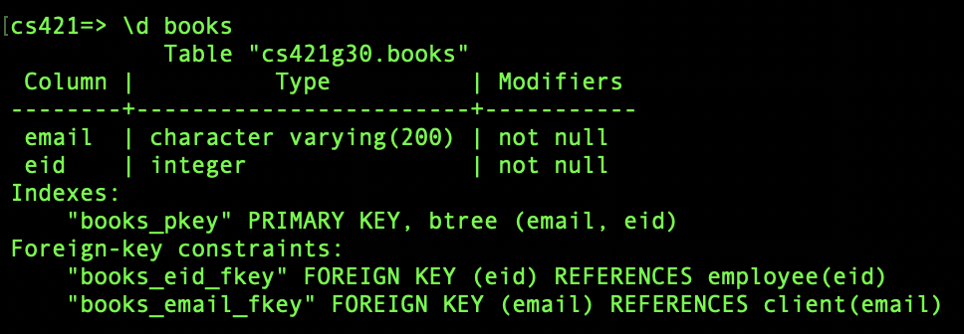

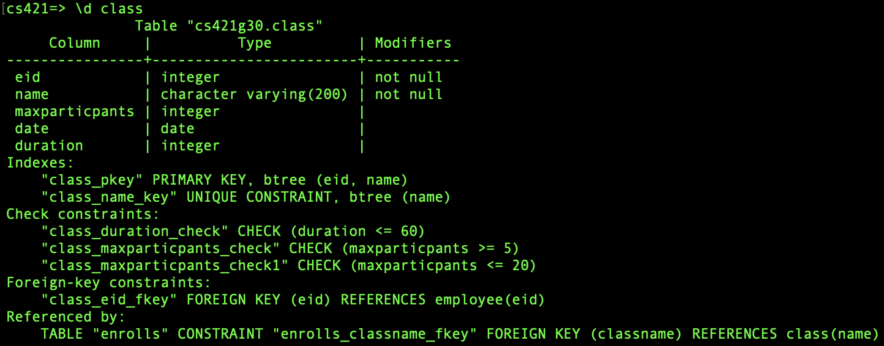

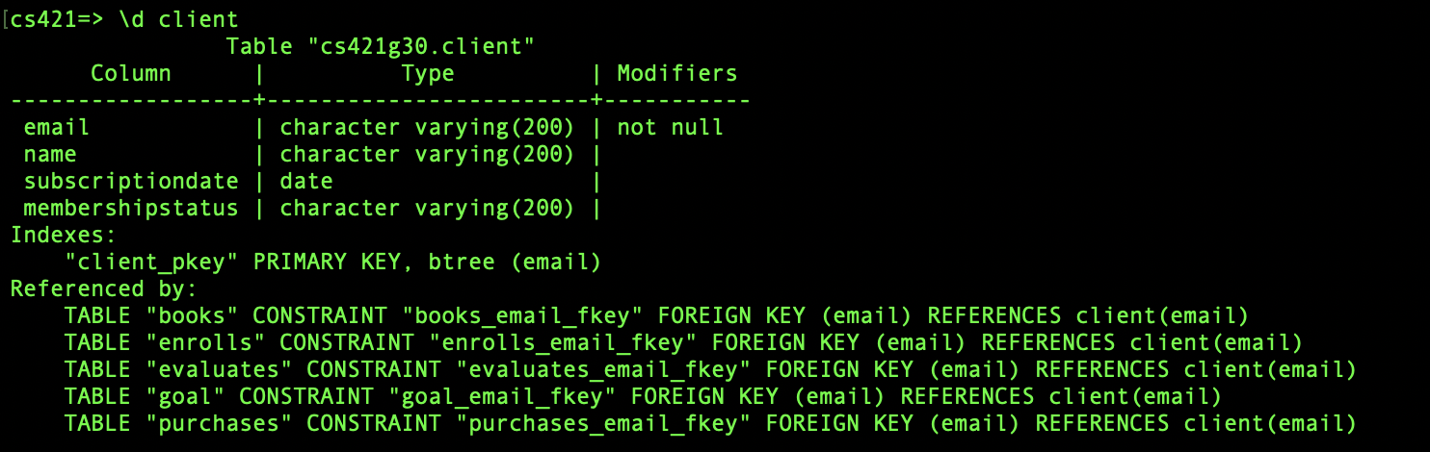

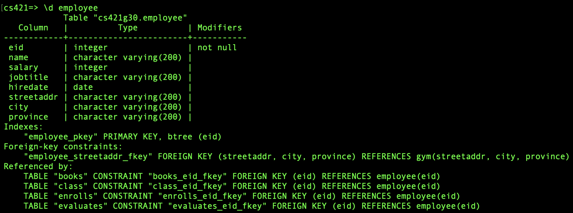

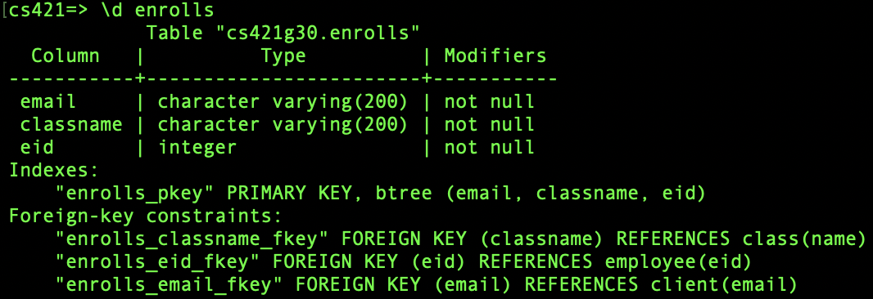

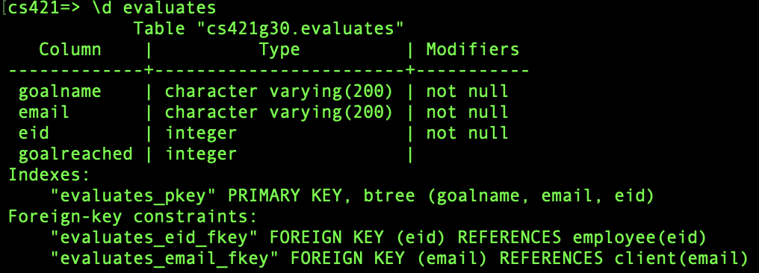

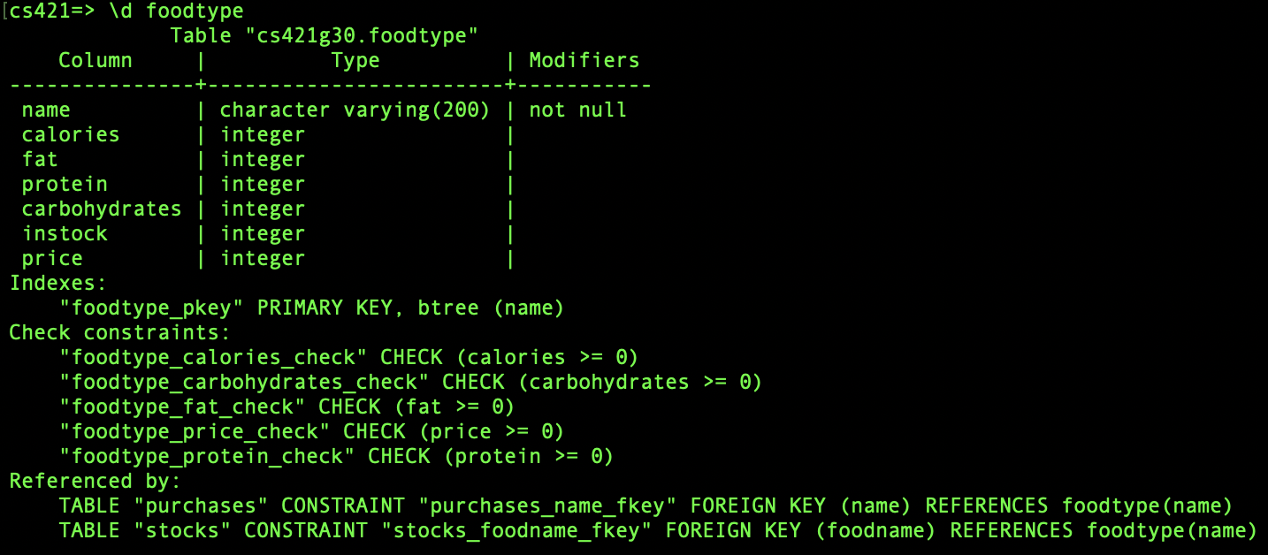

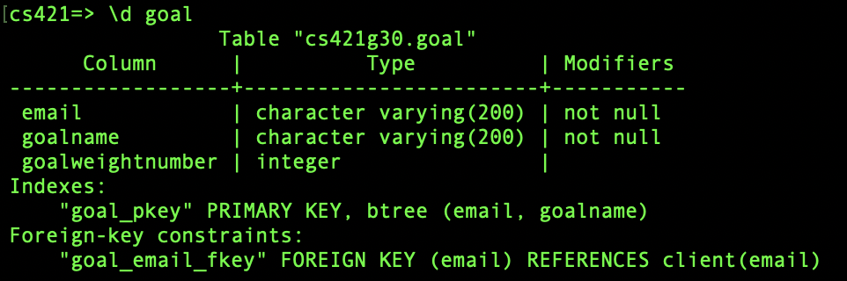



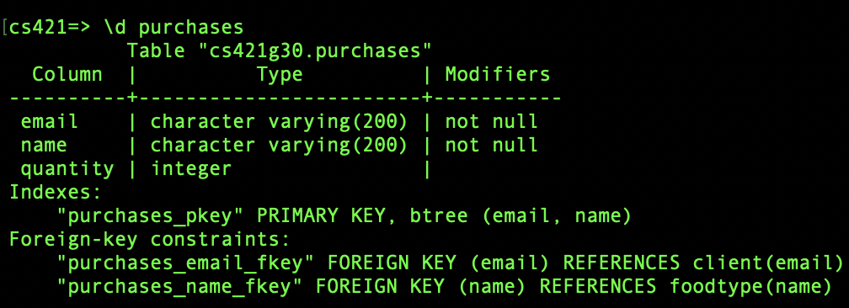







**3) INSERTIONS:**











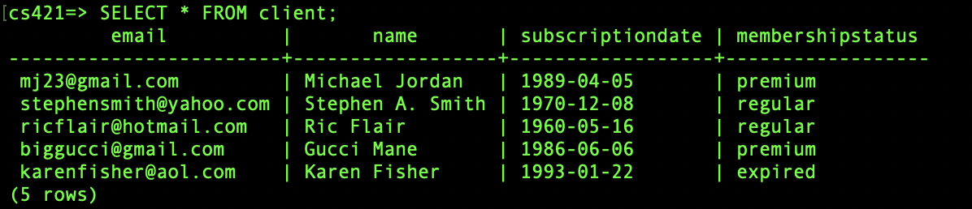

**4)**

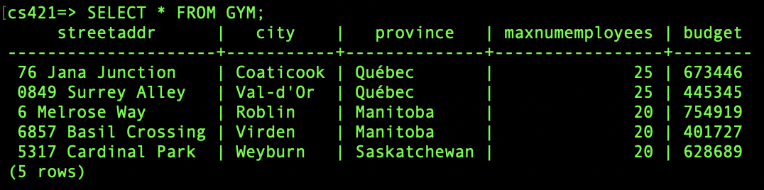

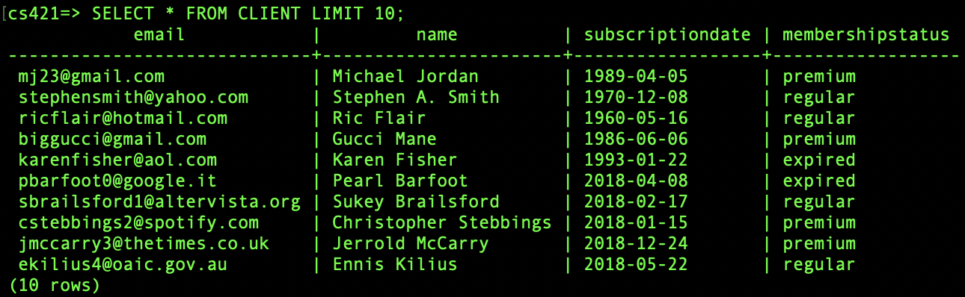

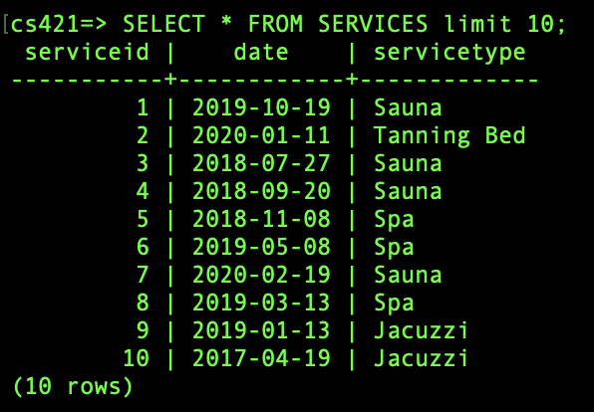



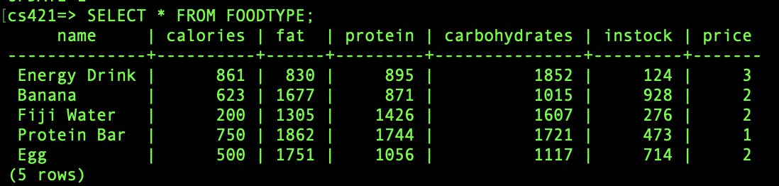

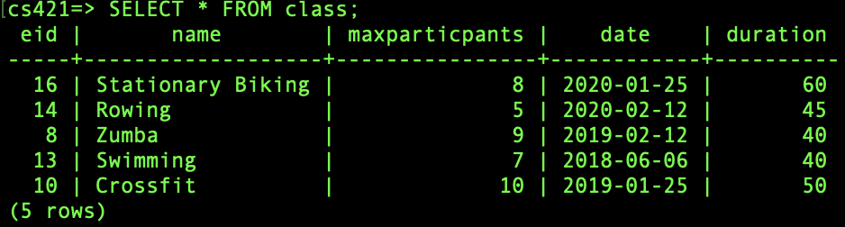

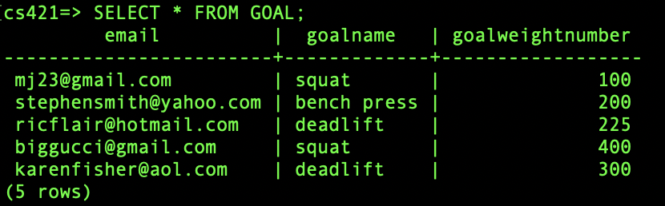

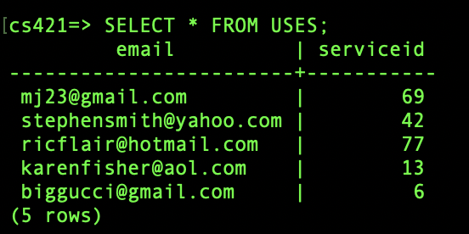

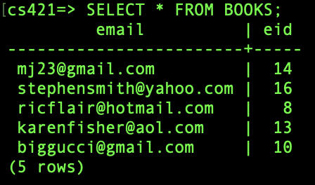

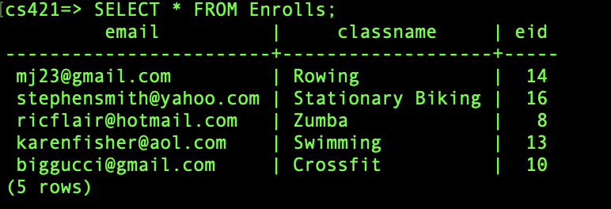

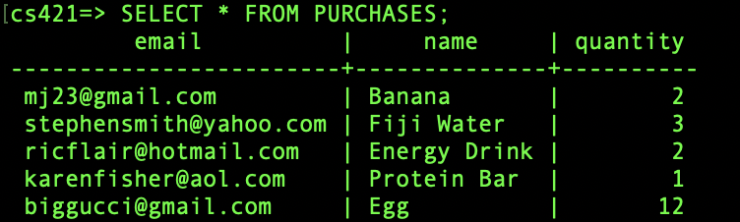

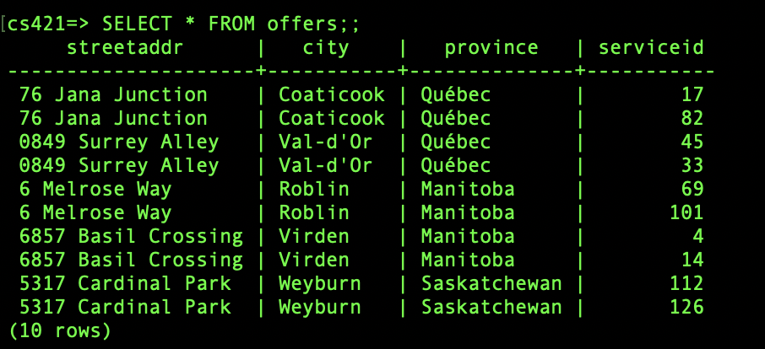

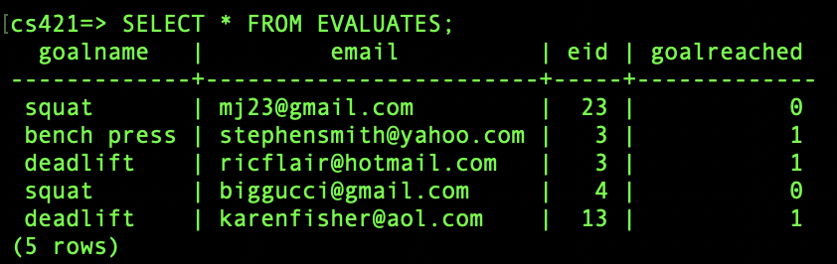

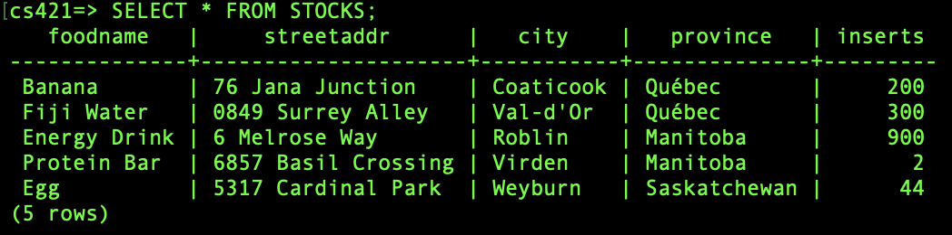

**5. SQL QUERIES**

* Aggregate all food nutritional values per client had purchased and how much money they spent
  + WITH agg AS(
  + SELECT CAST(AVG(calories) AS INT) AS avgCalories
  + , CAST(AVG(fat) AS INT) AS avgFat
  + , CAST(AVG(protein) AS INT) AS avgProtein
  + , CAST(AVG(carbohydrates) AS INT) AS avgCarbs
  + , email FROM purchases p
  + JOIN foodtype f ON p.name = f.name
  + GROUP BY email
  + )
  + , spent AS (
  + select SUM(price * quantity) AS totalSpent, email
  + FROM foodtype f
  + JOIN purchases p on f.name = p.name
  + GROUP BY p.email
  + )
  + SELECT agg.email
  + , agg.avgcalories, agg.avgcalories/ totalSpent AS caloriesPerDollar
  + , agg.avgfat, agg.avgfat/ totalSpent AS fatPerDollar
  + , agg.avgprotein, agg.avgprotein/ totalSpent AS proteinPerDollar
  + , agg.avgcarbs, agg.avgcarbs/ totalSpent AS carbsPerDollar
  + , p.totalSpent
  + FROM spent p
  + JOIN agg ON p.email = agg.email

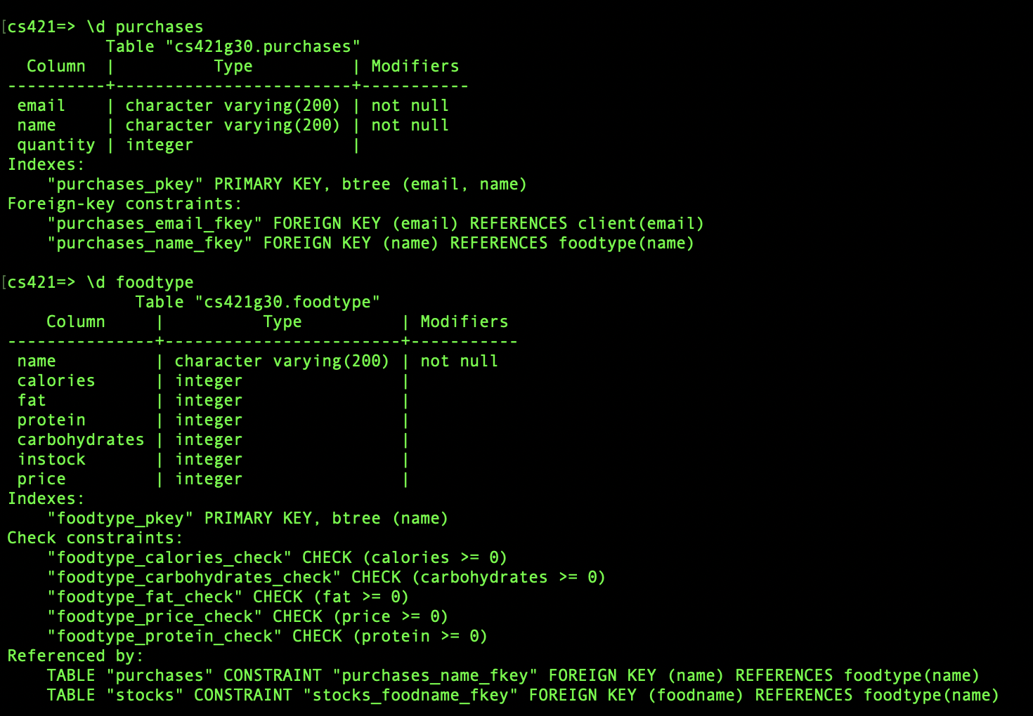

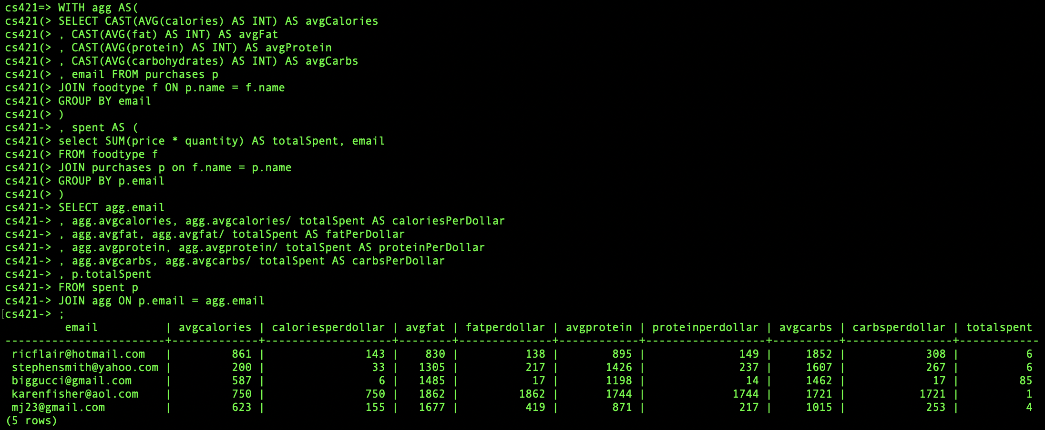

* Find the average weight goal for clients whose main exercise (goalName) is squats.
  + SELECT ROUND(AVG(goalWeightNumber)) FROM Goal WHERE goalName=’squat’;

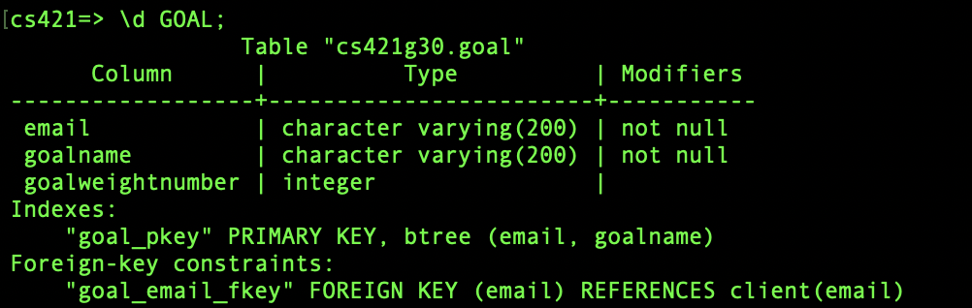

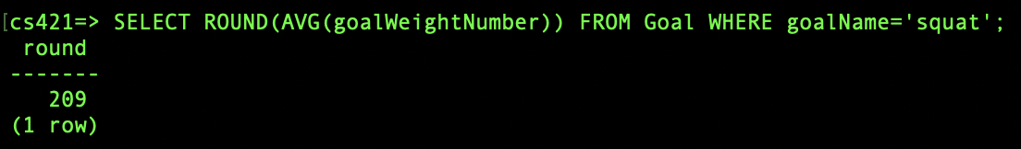

* Find all premium clients who are enrolled in a class (simple one)
  + SELECT COUNT(*) AS premiumMemberCount, classname FROM enrolls e JOIN client c ON e.email = c.email WHERE membershipstatus = 'premium' GROUP BY classname;

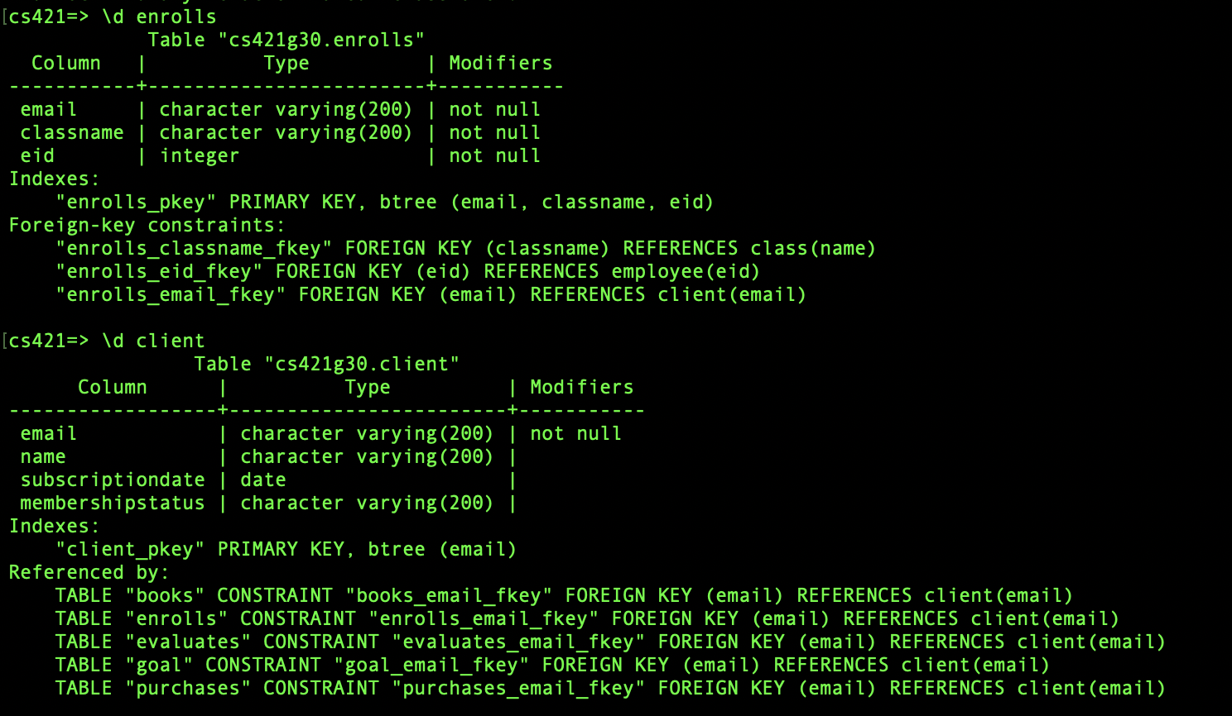



* Average employee salary grouped by employees by job title
  + SELECT ROUND(AVG(salary),0) AS avgSalary, jobtitle FROM employee GROUP BY jobtitle;

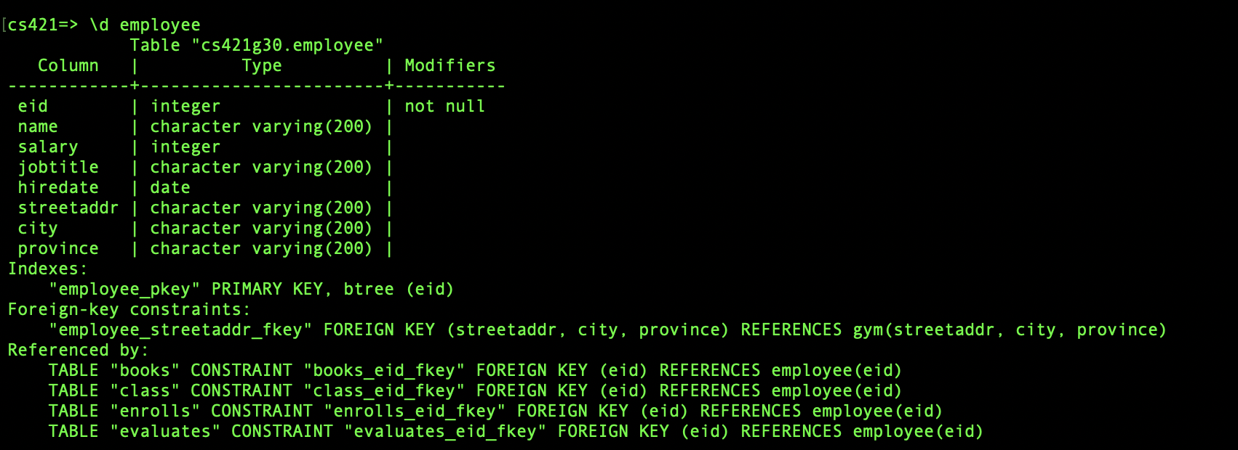

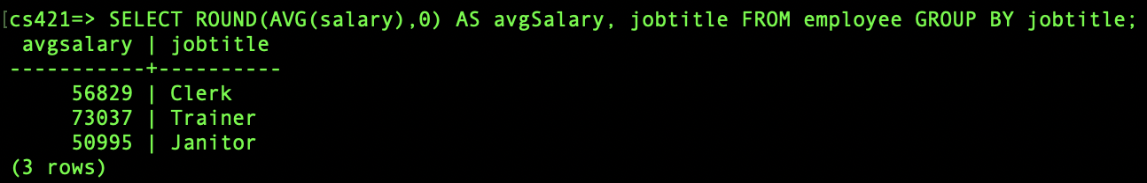

* Total salaries cost compared to budget per gym
  + SELECT gy.city, budget, SUM(salary) AS salaries FROM gym gy JOIN employee e ON gy.city = e.city GROUP BY gy.city, budget ORDER BY budget DESC;





**6. DATA MODIFICATIONS**

* Update - All gyms in Quebec get a budget increase of 100k;
  + UPDATE gym SET budget = budget + 100000 WHERE province = 'Québec'

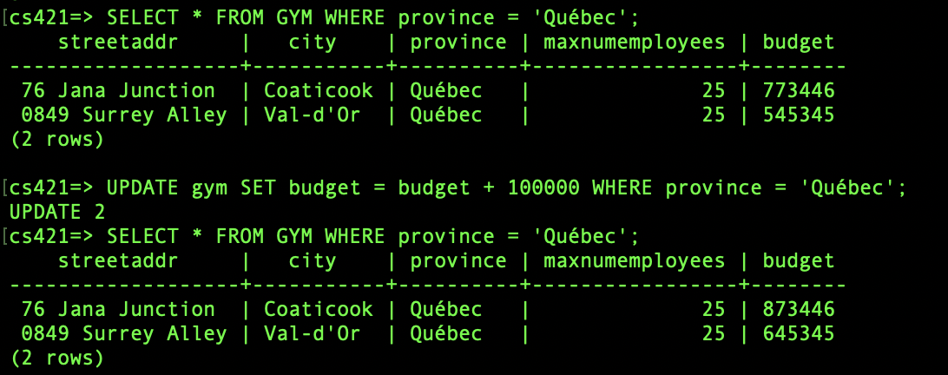

* Delete - all customers who have had expired membership over 1 year
  + SELECT * FROM client WHERE CAST(NOW() AS date) - subscriptiondate > 365 AND membershipstatus = 'expired'
  + DELETE FROM client WHERE CAST(NOW() AS date) - subscriptiondate > 365 AND membershipstatus = 'expired'

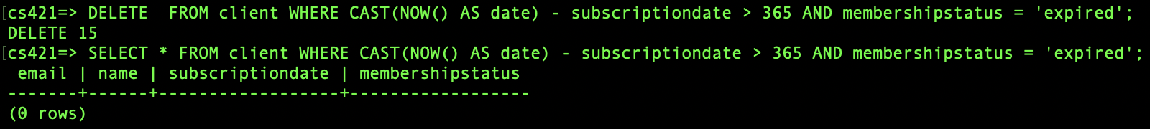

* Delete - Empty stock for foodtype if less than 50 objects are being inserted

SELECT * FROM stocks where inserts < 50;

DELETE FROM stocks where inserts < 50;

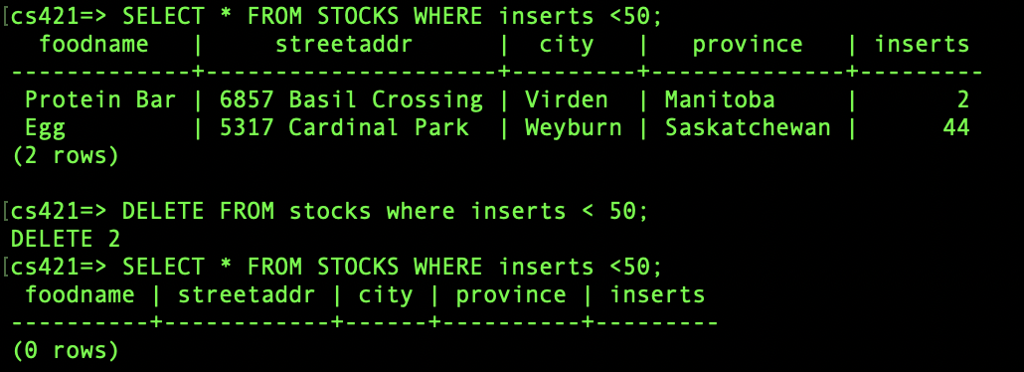

* Update - employees that teach more than one class(?) gets promotion, salary (+$5000) get updated in database
  + WITH a AS (
  + SELECT COUNT(*) classesTaught, e.eid
  + FROM class c
  + JOIN employee e ON c.eid = e.eid
  + GROUP BY e.eid
  + )
  + UPDATE employee
  + SET salary = salary + 5000
  + WHERE eid IN (SELECT eid FROM a WHERE classestaught > 1)

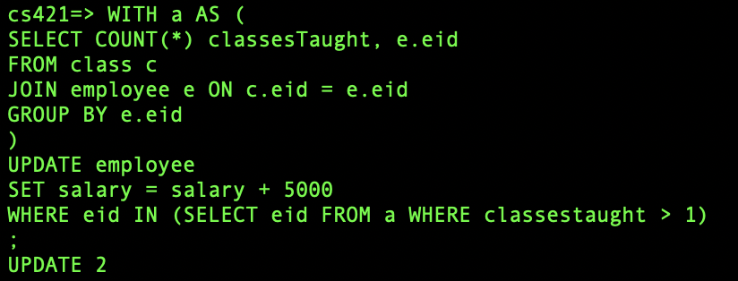

**7. Views**

* View 1 - A view of all employees with a salary greater than $70000.

CREATE VIEW HighestPaidEmployees AS  
SELECT eid, name, salary

FROM Employee

Where Salary >70000;



The query “select * from HighestPaidEmployees where eid < 10” was executed.

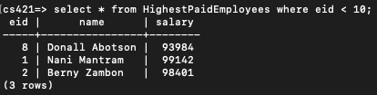

The following “update” statement was executed

UPDATE HighestPaidEmployees

SET name = ‘Big Baller’

WHERE eid = 8;



View 1 is updatable as the view is defined based on only one table, and

includes the PRIMARY KEY of the base table.

* View 2 - A view of all the clients that have subscribed for a premium membership

CREATE VIEW PremiumClients AS  
SELECT email, name, membershipstatus

FROM Client

Where membershipstatus=‘premium’;



The query “SELECT * FROM PremiumClients WHERE name LIKE 'A%';” was executed.

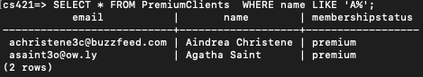

The following “update” statement was executed

UPDATE PremiumClients

SET name = ‘valued customer’

WHERE email = ‘asaint3o@ow.ly’;



View 2 is updatable as the view is defined based on only one table, and

includes the PRIMARY KEY of the base table.

**8. CHECK Restraints**

* Check that when FoodType is created, calories, fat, protein, carbs, and price are all greater than or equal to 0.

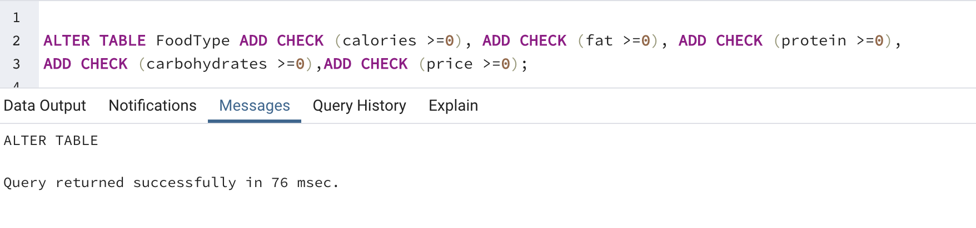

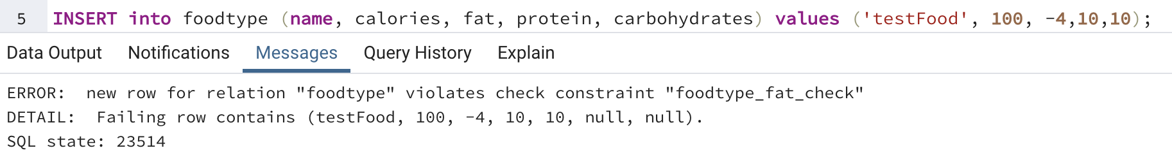

2. Class durations cannot exceed a certain hour, maxParticipants can only be between 5-20 people

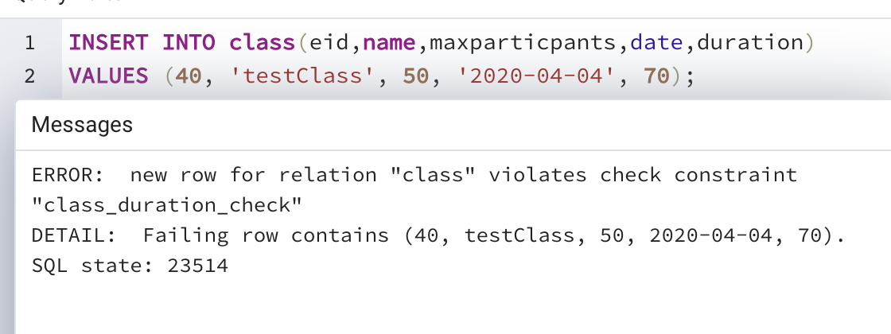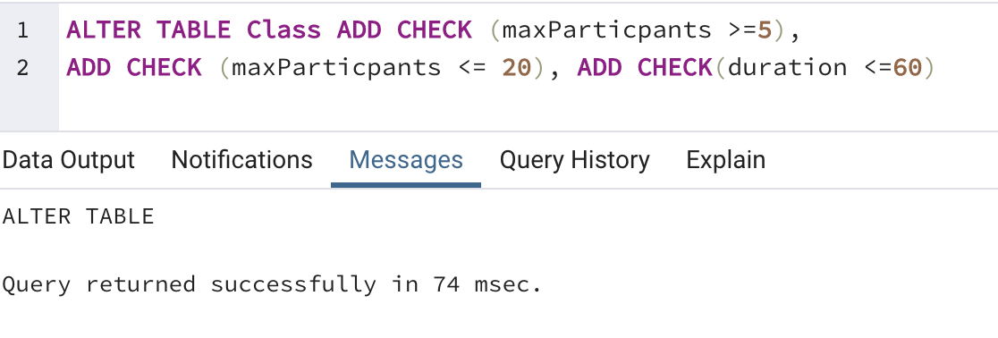

**9. Creativity Points**

* Used mockaroo.com for data generation for several tables that represent legitimate data
* Data generated represent ‘real-life’ data that can be queried and analyzed to represent realistic findings
* We have Fancy SQL queries in #5 that the professor did not teach, such as WITH AS, NOW()